Nationals Performance Events
Friday October 21

AKC Rally and Obedience Trials 8:30 -12:00
Judge: Marleen Burford
Event Coordinator: Rhoda Bennett

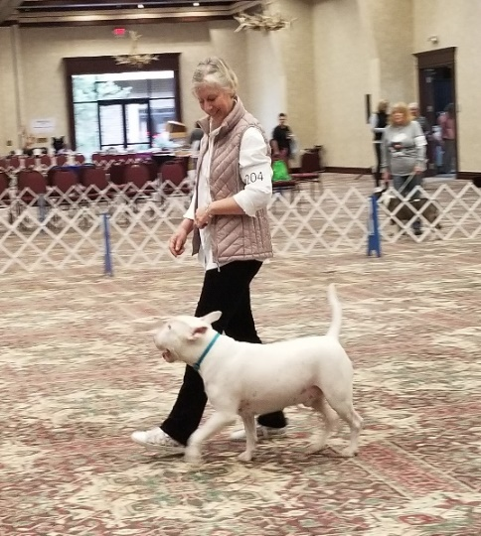
High in Trial and 1st in each class to receive stained glass Bull Terrier art by Donna Bryant

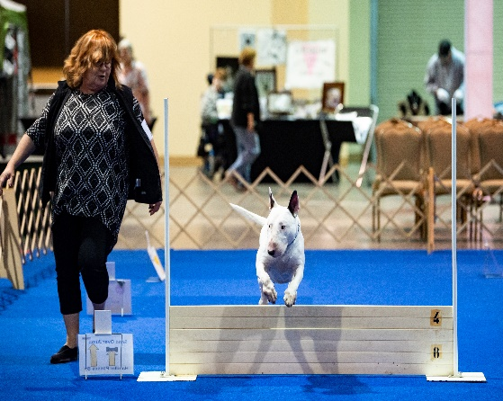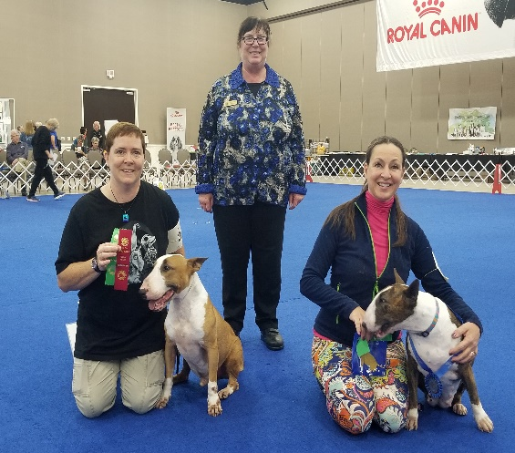
The Gordon Bane Memorial Obedience award will be presented following the trial for highest score in the regular or preferred classes.

