Nationals Performance Events
Thursday Oct 20th
Start practicing now to get your AKC Tricks and CGC titles !
Tricks Title testing 8-9:30 am
Evaluator: Susan Belden, sebelden@me.com
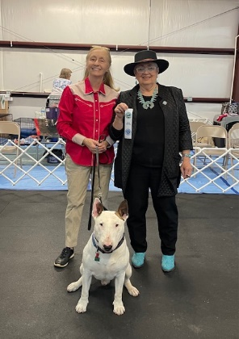
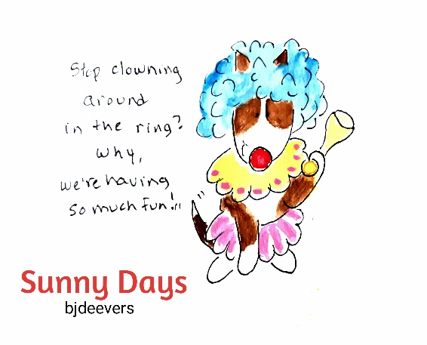
All Tricks entries entered into a raffle to win a 6 print Shutterfly canvas back easel of Bull Terriers doing Tricks
Canine Good Citizen / GGCA 1:30-4
Preregister with Sharon by Wed 10/12 to ensure a spot, day of taken if time

Evaluator: Sharon Whalen-Keillor keylore@yahoo.com
1-1:30 CGC Clinic/ walk through
1:30-4 CGC/CGCA testing
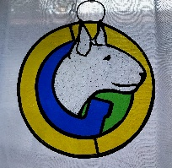
All passing CGC/CGCAs to receive Stained glass suncatcher by Donna Bryant !

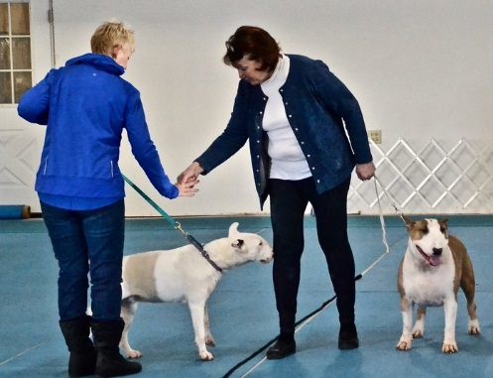

For Bull Terrier CGC video click here

For test details, go to AKC.org

